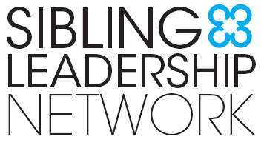

Position Description
Communications Consultant
Sibling Leadership Network

Background
The Sibling Leadership Network (SLN) is a national nonprofit organization dedicated to providing siblings of individuals with disabilities the information, support, and tools to advocate with their brothers and sisters and to promote the issues important to them and their entire families. For more details visit the SLN website at www.siblingleadership.org.

Position Overview
The Sibling Leadership Network seeks a part-time Communications Consultant to provide technical administration of a Wordpress website, Facebook, Twitter and Mailchimp accounts. The Communications Consultant will also work in conjunction with the SLN Executive Director and SLN Project Manager to develop and disseminate SLN-related content. This person will manage the communications calendar and have a monthly communications call with the SLN Executive Director to map out the content for the coming month. Also, other communications/administrative duties may be requested as needed. This position works remotely.

Qualifications
The Communications Consultant will have:
- Strong oral and written communication
- Experience in developing communication messages for various audiences
- Proficiency in Wordpress, Facebook, Twitter and Mailchimp
- An understanding of the values and mission of the SLN, which will be translated into content across the above platforms
- A willingness to work collaboratively with nonprofit volunteer members and the Executive Director

This is an hourly position, estimated at about 10-15 hours per month. Hourly wage $18-22 per hour. Anticipated start date is December 2, 2019.

Application Process
If interested, please contact Katie Arnold, SLN Executive Director, at Katie.Arnold@siblingleadership.org. Please include an updated resume, a cover letter describing why you would be an asset to the organization, and three examples of how you would improve/update the SLN communications strategy/content.

